Nu Game Engine

Bryan Edds, 2014

# Table of Contents

Table of Contents 2

What’s It All About? 3

Very Basic 3

Purely-Functional(ish) 3

2d Game Engine 3

F# 3

Getting Started 4

Running the Nu Project (Nu.exe) 5

Basic Nu Start-up Code 6

What is NuEdit? 7

BlazeVector 12

The Game Engine 15

World 15

Screen 16

Transition(s) 16

Group 16

Entity 16

Engine Details 16

Addresses 16

Transformations 17

XDispatchers, XFields, and the Xtension system 17

Assets and the AssetGraph 17

Subsystems and Message Queues 17

Facets 18

# What’s It All About?

The Nu Game Engine is a **Very** **Basic**, **Purely-Functional**(ish), **2d Game Engine** written in **F#**.

Let me explain each of those terms –

## **Very Basic**

Nu is very young, and so it has just about no frills. Is there a particle or special effects system? Not yet, I’m afraid. Is there a sprite animation system? Again, not yet. However, there is a tile map system that utilizes Tiled#, and there is a physics system that utilizes Farseer Physics. Rendering, audio, and other IO systems are handled in a cross-platform way with SDL2 / SDL2#. In addition to that, there is an asset management system to make sure your game can run on memory-constrained devices such as the iPhone. On top of all that, there is a built-in game editor called NuEdit! So while there are plenty of missing features, you can see they might be worth waiting for, or even building for yourself!

## **Purely-Functional(ish)**

Nu is built on immutable types, and unlike with other game engines, data transformations and state transitions are implemented with copying rather than mutation.

Don’t mistake Nu for being slow, however. Notice I said Purely-Functional-ish. The ‘ish’ means that there are some imperative operations going on in Nu, almost entirely behind the scenes. For example, the Farseer physics system is written in an imperative style in C#, and some parts of Nu are optimized with imperative code as well. Fortunately, nearly all of this will be transparent to you as the user. When writing code that utilizes, feel empowered to write in the pure-functional style.

## **2d Game Engine**

Nu is not a code library. It is a game software framework, and thus sets up a specific way of approaching and thinking about the design of 2d games. Of course, Nu is intended to be a broadly generic toolkit for 2d game development, but there are some design choices that may sometimes constrain you as much as they help you. Figure out how to leverage Nu’s design for your game. If it’s a complete mismatch, it might be time to consider using something else.

## **F#**

We know what F# is, so why use it? First, and foremost, its cross-platformedness. Theoretically, Nu should run fine on Mono for systems such as Android, iOS, OSX, and *nixes. It definitely runs on .NET for Windows. Note my weasel-word “theoretically”; Nu is still in such an early stage that it has yet to be configured, deployed, or tested on Mono. Nonetheless, since Nu only takes dependencies on cross-platform libraries, there should be no reason why it can’t with a little bit of appropriate nudging.

But more on why F#. F# is probably the best mainstream language available for writing a cross-platform functional game engine. Unlike Clojure, F#’s static type system makes the code easier to reason about and dare I say more efficient. Unlike JVM languages, F# allows us to code and debug with Visual Studio. Finally, I speculate that game developers have more familiarity with the .NET ecosystem than the JVM, so that leverage is right there.

# Getting Started

Nu currently does not have a binary distribution. Instead it has a github repository at <https://github.com/bryanedds/FPWorks>. I’m going to assume you know (or can quickly figure out) how to pull down the git repository on your own. Please take note of the license when pulling down the repository.

The first thing you might notice about the repository is that it contains more than just the Nu Game Engine. It also includes the source for the Aml programming language, the Prime F# code library, the sample game BlazeVector (which we’ll be studying in this document), my WIP role-playing game OmniBlade, and some other loosely related stuff. Aml, Prime, and BlazeVector are required to build the BlazeVector solution we’ll be opening in this tutorial, and the rest of the stuff is safely ignored.

To open the BlazeVector solution, first make sure to have Visual Studio 2013 installed (or perhaps an earlier version – not tested!) Then navigate to the ./BlazeVector/BlazeVector folder and open the BlazeVector.sln file. Attempt to build the whole solution. If there is a problem with building it, try to figure it out, and failing that, ask me questions via [bryanedds@gmail.com](mailto:bryanedds@gmail.com).

# Running the Nu Project (Nu.exe)

Once you have built the solution, try running the standalone engine by setting the Nu project as the StartUp Project, and then running.

When the app is run from Visual Studio, you’ll notice a window popping up that is filled with a nice white color. By default, Nu does nothing but clear the frame buffer with white pixels. There is no interactivity in this program, as the engine is not yet being told to do anything.

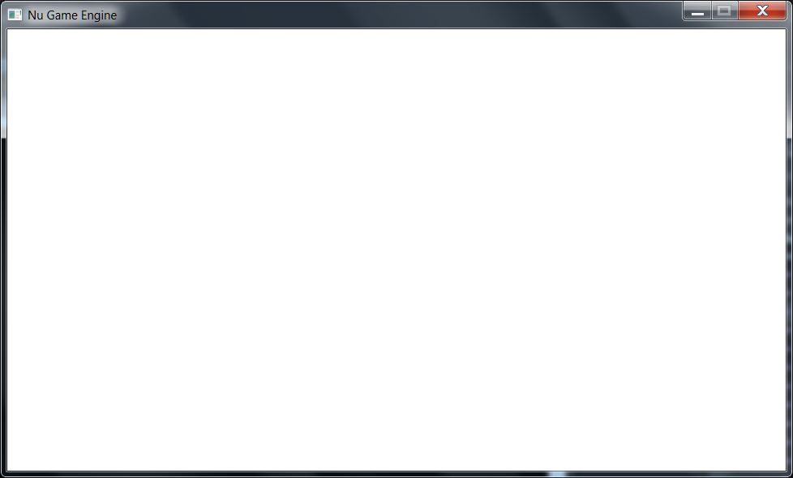

Though this is not an interesting program, a look at the code behind it should be enlightening.

## Basic Nu Start-up Code

Here’s the main code presented with comments -

// Nu Game Engine.

// Copyright (C) Bryan Edds, 2013-2014.

namespace Nu

open SDL2

open Nu

open Nu.NuConstants

module Program =

// this the entry point for the empty Nu application

let [<EntryPoint>] main _ =

// this initializes miscellaneous values required by the engine. This should always be the

// first line in your game program.

World.init ()

// this specifies the manner in which the game is viewed. With this configuration, a new

// window is created with a title of "Nu Game Engine".

let sdlViewConfig =

NewWindow

{ WindowTitle = "Nu Game Engine"

WindowX = SDL.SDL_WINDOWPOS_UNDEFINED

WindowY = SDL.SDL_WINDOWPOS_UNDEFINED

WindowFlags = SDL.SDL_WindowFlags.SDL_WINDOW_SHOWN }

// this specifies the manner in which the game's rendering takes place. With this

// configuration, rendering is hardware-accelerated and synchronized with the system's

// vertical re-trace, making for fast and smooth rendering.

let sdlRendererFlags =

enum<SDL.SDL_RendererFlags>

(int SDL.SDL_RendererFlags.SDL_RENDERER_ACCELERATED |||

int SDL.SDL_RendererFlags.SDL_RENDERER_PRESENTVSYNC)

// this makes a configuration record with the specifications we set out above.

let sdlConfig =

{ ViewConfig = sdlViewConfig

ViewW = ResolutionX

ViewH = ResolutionY

RendererFlags = sdlRendererFlags

AudioChunkSize = AudioBufferSizeDefault }

// this is a callback that attempts to make 'the world' in a functional programming

// sense. In a Nu game, the world is represented as a complex record type named World.

let tryMakeWorld sdlDeps =

// Game dispatchers specify some unique, high-level behavior and data for your game.

// Since this particular program has no unique behavior, the vanilla base class

// GameDispatcher is used.

let gameDispatcher = GameDispatcher () :> obj

// here is an attempt to make the world using SDL dependencies that will be created

// from the invoking function using the SDL configuration that we defined above, the

// gameDispatcher immediately above, and a value that could have been used to

// user-defined data to the world had we needed it (we don't, so we pass unit).

World.tryMakeEmpty sdlDeps gameDispatcher true ()

// this is a callback that specifies your game's unique behavior when updating the world

// every tick. The World value is the state of the world after the callback has transformed

// the one it receives. It is here where we first clearly see Nu's purely-functional(ish)

// design. The World type is almost entirely immutable, and thus the only way to update it

// is by making a new copy of an existing instance. Since we need no special update

// behavior in this program, we simply return the world as it was received.

let updateWorld world = world

// after some configuration it is time to run Nu. We're off and running!

World.run tryMakeWorld updateWorld sdlConfig

Hopefully that was somewhat enlightening. You can find this code from Visual Studio in the Program.fs file of the Nu project in the Nu.sln solution.

When creating a new Nu game project, you can copy and modify this file into your project to use as a template for your program. Creating a new Nu game project is mostly just creating a new F# program project, setting up the references, and using said code as a template.

Before discussing Nu’s game engine design, let’s have a little fun messing around with Nu’s real-time interactive game editor, NuEdit.

# What is NuEdit?

NuEdit is Nu’s fairly usable game editor. Here is a screenshot of an empty editing session –

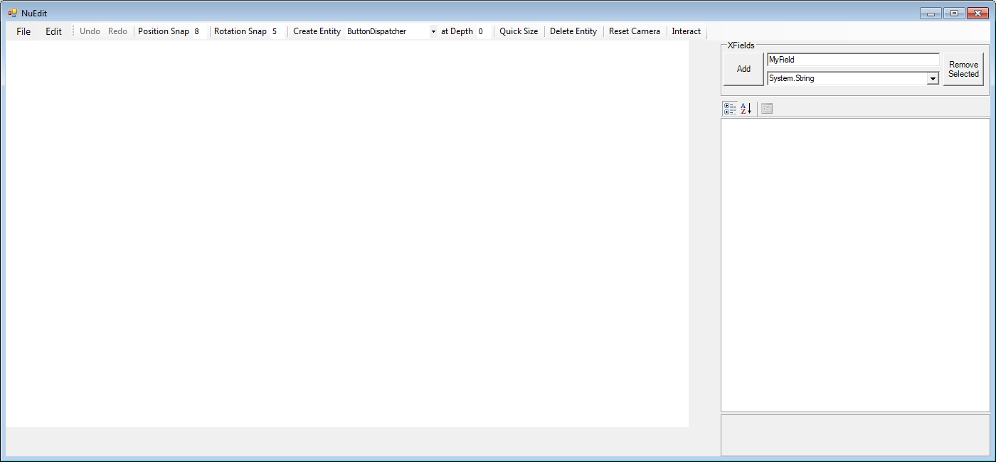

***NOTE:*** *There may still be some stability issues with NuEdit, so save your documents early and often, and for goodness’ sake use a source control system!*

Run NuEdit by setting the NuEdit project as the StartUp Project in Visual Studio, and then running.

First, we’ll create a blank button by ensuring that ButtonDispatcher is selected in the combo box to the right of the Create Entity button on the main tool bar, and then pressing the Create Entity button.

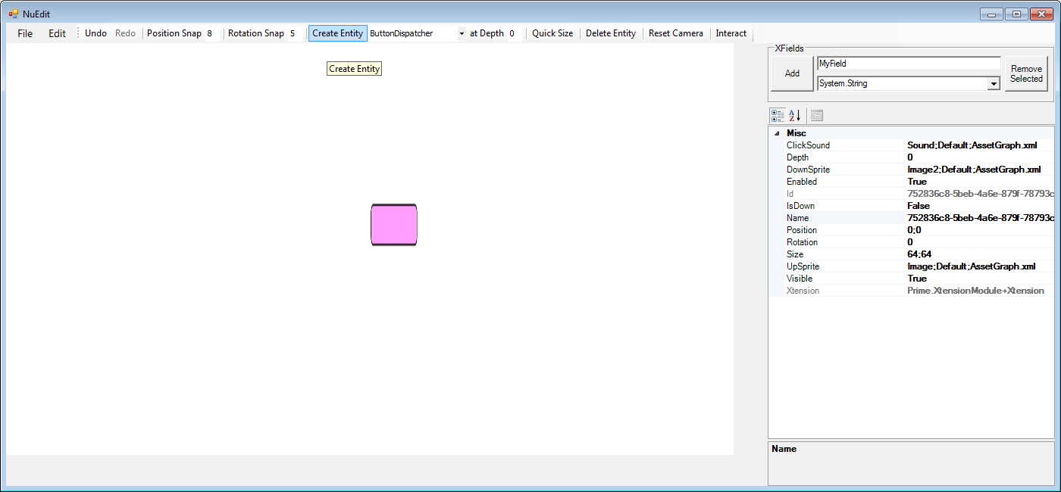

You’ll notice a squished button appear in the middle of the editing panel. By default, most entities are created as a 64x64 sprite. Fortunately, Nu gives you an easy way to resize the sprite to fit the button’s image by pressing the Quick Size button. Press it now.

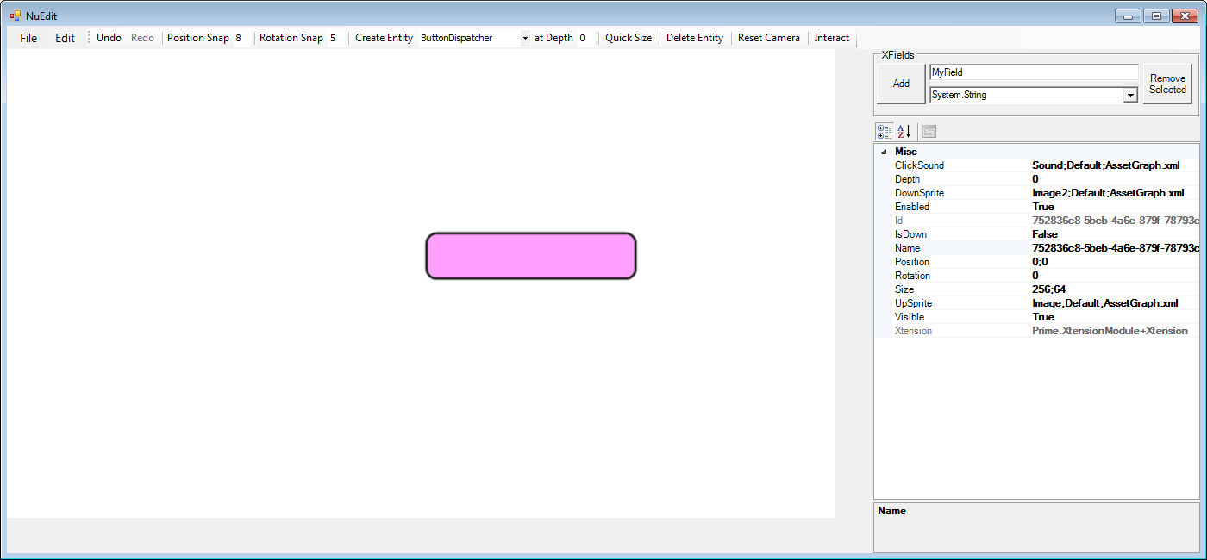

We have a full button! Notice the property grid on the right got filled with various field names and their corresponding values. These values can be edited manually. For an entity that will be used to control the game’s state (like a button), the first thing you will want to do is to give it an appropriate name. Simply double-click the Name field, delete the contents, and then enter the text “MyButton”. Naming entities give you the ability to access them at runtime via that name once you have loaded the containing document in your game.

Notice also that you can click and drag on the button to move it about the screen. Once an entity is selected, you can also right-click it for more operations.

Here we’ve renamed the button and moved it to the bottom right of the screen –

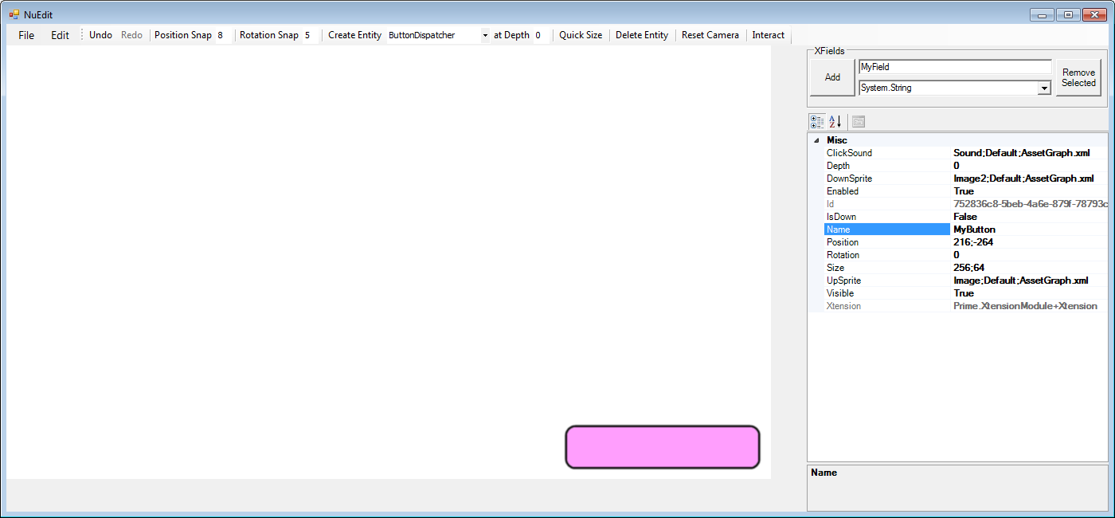

Notice you have the full power of undo and redo. Nonetheless, you should still save your documents often in case this early version of NuEdit goes bananas on you.

Let’s now try putting NuEdit in interactive mode so that we can test that our button clicks as we expect. Toggle on the Interact button at the top right, then click on the button.

Once you’re satisfied, toggle off the Interact button to return to editing mode.

Now let’s make a default tile map to play around with. BUT FIRST, we need to change the depth of our button entity so that it doesn’t get covered by the new tile map! Change the value in the button’s Depth field to 10.

In the drop down box to the right of the Create Entity button, select (or type) TileMapDispatcher, and then press the Create Entity button, and then click the Quick Size button. You’ll get this –

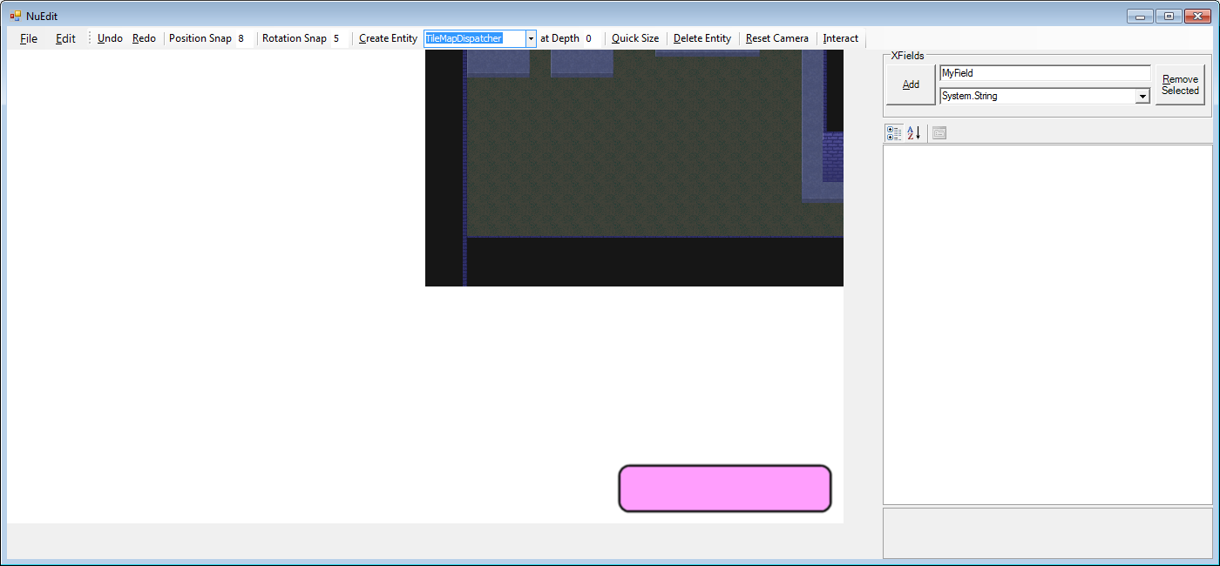

Click and drag the tile map so its bottom-left corner lines up with the top left of the editing panel.

Tile maps, by the way, are created with the free tile map editor Tiled found at <http://www.mapeditor.org/>. All credit to the great chap who made and maintains it!

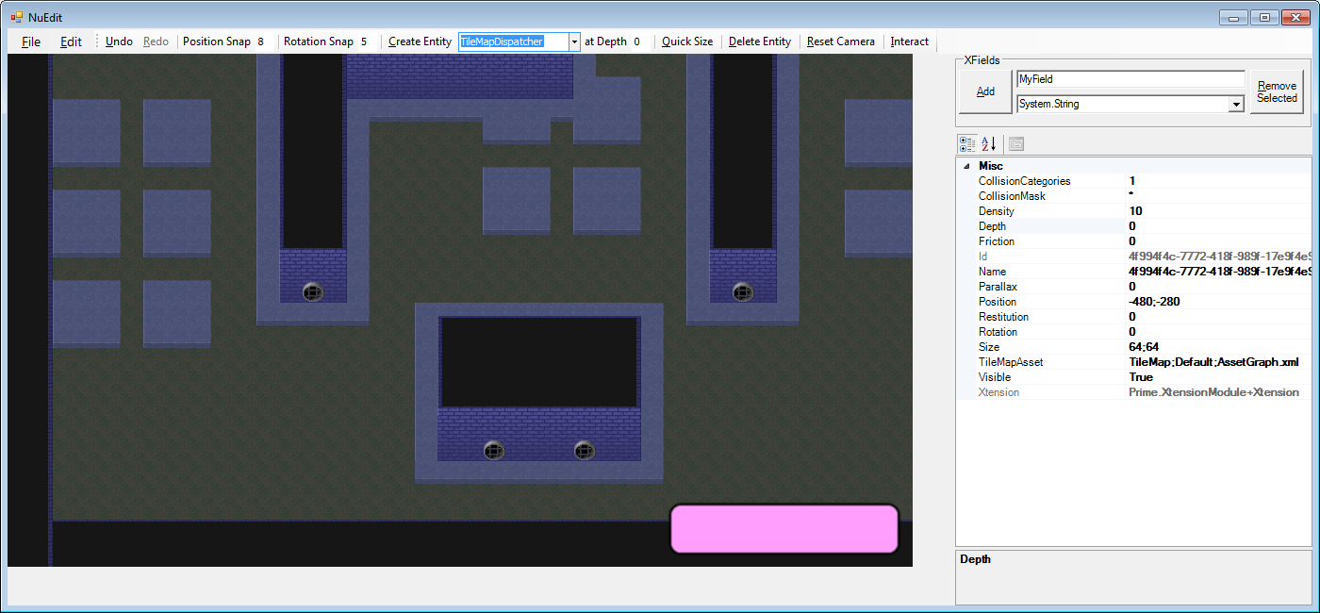

Now click and drag with the MIDDLE mouse button to change the position of the camera that is used to view the game. Check out your lovely new tile map! If your camera gets lost in space, click the Reset Camera button that is to the left of the Interact button.

Now let’s create some blocks to fall down and collide with the tile map using physics. First, we must change the default depth at which new entities are created (again, so the tile map doesn’t overlap them). In the at Depth text box to the left of the Quick Size button, type in a 1. In the combo box to the right of the Create Entity button, select (or type) BlockDispatcher, and then click the Create Entity button. You’ll see a box created in the middle of the screen that falls directly down.

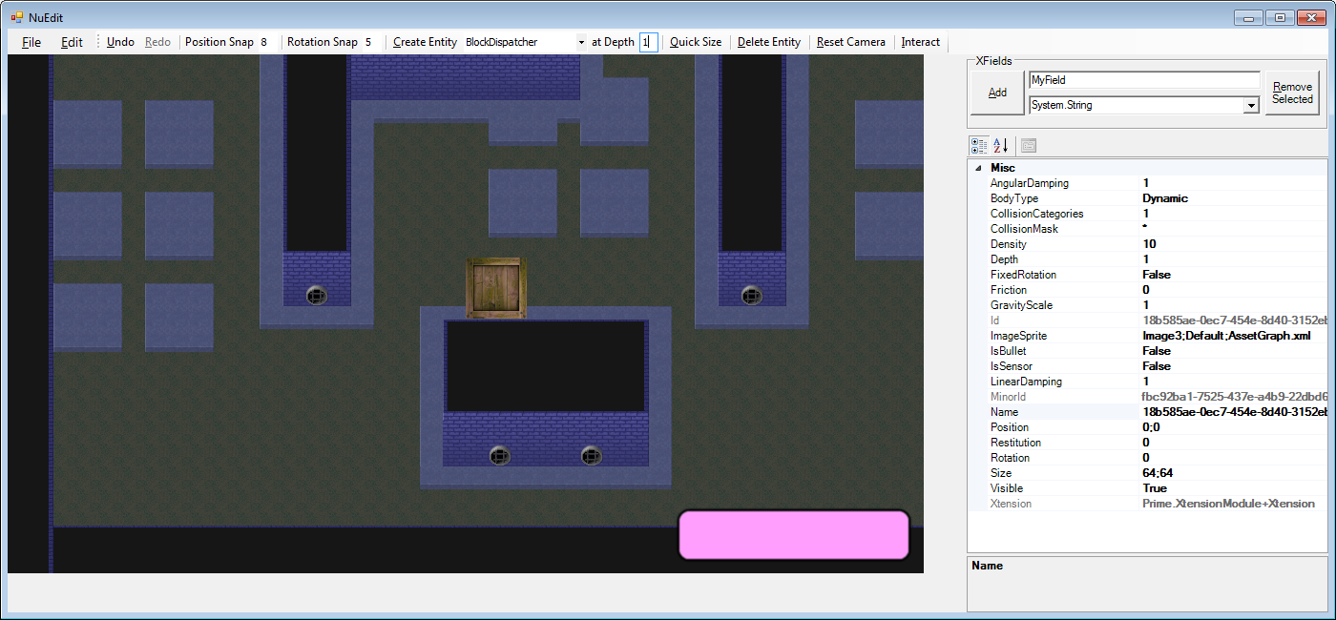

Notice that you can create blocks in other places by right-clicking at the desired location and then, in the context menu that pops up, clicking Create.

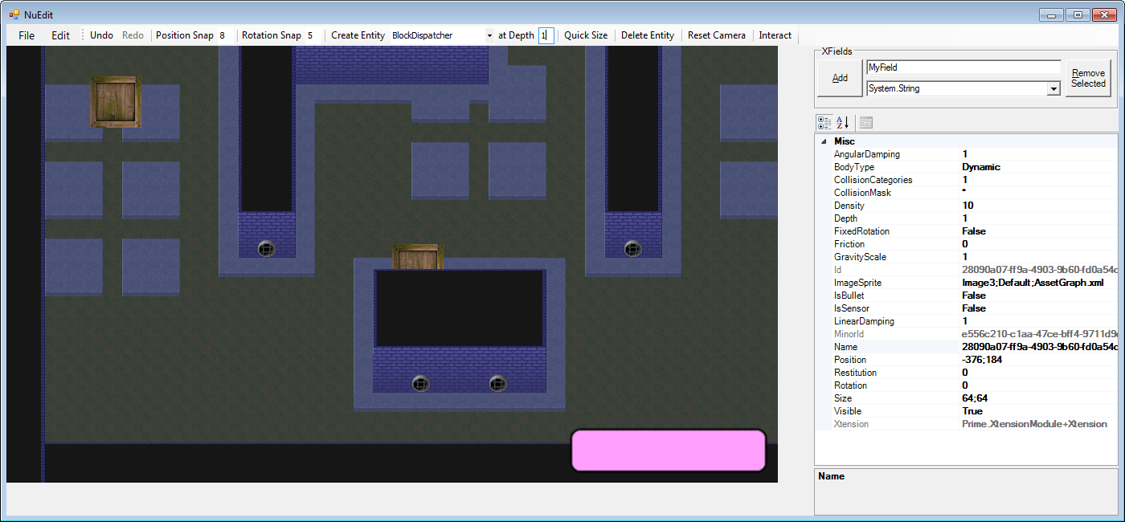

Blocks can be clicked and dragged around like other entities.

We can now save the document for loading into a game by clicking File -> Save…

Lastly, we can add custom fields (known as XFields) to each entity by selecting it on the screen and pressing the Add button in the XFields box atop the property grid. We have no use for this now, however, so we won’t click anything further.

Let’s watch Nu in action with the sample game called BlazeVector.

# BlazeVector

This is the sample game for the Nu Game Engine. In Visual Studio, set the BlazeVector project as the StartUp Project, and then run. We can look at how Nu hangs together a bit by studying BlazeVector’s top level code.

First, however, we need to go over the constants that BlazeVector uses. These are defined in the BlazeConstants.fs file –

namespace BlazeVector

open Nu

open Nu.NuConstants

module BlazeConstants =

// misc constants. These, and the following constants, will be explained in depth later. Just

// scan over them for now, or look at them in the debugger on your own.

let GuiPackageName = "Gui"

let StagePackageName = "Stage"

let StagePlayerName = "Player"

let StagePlayName = "StagePlay"

let StagePlayFileName = "Assets/BlazeVector/Groups/StagePlay.nugroup"

let SectionName = "Section"

let Section0FileName = "Assets/BlazeVector/Groups/Section0.nugroup"

let Section1FileName = "Assets/BlazeVector/Groups/Section1.nugroup"

let Section2FileName = "Assets/BlazeVector/Groups/Section2.nugroup"

let Section3FileName = "Assets/BlazeVector/Groups/Section3.nugroup"

let SectionFileNames = [Section0FileName; Section1FileName; Section2FileName; Section3FileName]

let SectionCount = 32

// asset constants

let NuSplashSound = { SoundAssetName = "Nu"; PackageName = GuiPackageName; PackageFileName = AssetGraphFileName }

let MachinerySong = { SongAssetName = "Machinery"; PackageName = GuiPackageName; PackageFileName = AssetGraphFileName }

let DeadBlazeSong = { SongAssetName = "DeadBlaze"; PackageName = StagePackageName; PackageFileName = AssetGraphFileName }

let HitSound = { SoundAssetName = "Hit"; PackageName = StagePackageName; PackageFileName = AssetGraphFileName }

let ExplosionSound = { SoundAssetName = "Explosion"; PackageName = StagePackageName; PackageFileName = AssetGraphFileName }

let ShotSound = { SoundAssetName = "Shot"; PackageName = StagePackageName; PackageFileName = AssetGraphFileName }

let JumpSound = { SoundAssetName = "Jump"; PackageName = StagePackageName; PackageFileName = AssetGraphFileName }

let DeathSound = { SoundAssetName = "Death"; PackageName = StagePackageName; PackageFileName = AssetGraphFileName }

// transition constants

let IncomingTimeSplash = 60L

let IncomingTime = 20L

let IdlingTime = 60L

let OutgoingTimeSplash = 40L

let OutgoingTime = 30L

let StageOutgoingTime = 90L

// splash constants

let SplashAddress = addr "Splash"

// title constants

let TitleAddress = addr "Title"

let TitleGroupFileName = "Assets/BlazeVector/Groups/Title.nugroup"

let TitleGroupAddress = addr "Title/Group"

let SelectTitleEventName = addr "Select/Title"

let ClickTitlePlayEventName = addr "Click/Title/Group/Play"

let ClickTitleCreditsEventName = addr "Click/Title/Group/Credits"

let ClickTitleExitEventName = addr "Click/Title/Group/Exit"

// stage constants

let StageAddress = addr "Stage"

let StageGroupFileName = "Assets/BlazeVector/Groups/StageGui.nugroup"

let StageGroupAddress = addr "Stage/Group"

let ClickStageBackEventName = addr "Click/Stage/Group/Back"

// credits constants

let CreditsAddress = addr "Credits"

let CreditsGroupFileName = "Assets/BlazeVector/Groups/Credits.nugroup"

let CreditsGroupAddress = addr "Credits/Group"

let ClickCreditsBackEventName = addr "Click/Credits/Group/Back"

Nothing terribly interesting, so let’s jump to Program.fs -

namespace BlazeVector

open System

open SDL2

open Nu

open Nu.NuConstants

open BlazeVector

module Program =

// this the entry point for the BlazeVector application

let [<EntryPoint>] main _ =

// this initializes miscellaneous values required by the engine. This should always be the

// first line in your game program.

World.init ()

// this specifies the manner in which the game is viewed. With this configuration, a new

// window is created with a title of "BlazeVector".

let sdlViewConfig =

NewWindow

{ WindowTitle = "BlazeVector"

WindowX = SDL.SDL_WINDOWPOS_UNDEFINED

WindowY = SDL.SDL_WINDOWPOS_UNDEFINED

WindowFlags = SDL.SDL_WindowFlags.SDL_WINDOW_SHOWN }

// this specifies the manner in which the game's rendering takes place. With this

// configuration, rendering is hardware-accelerated and synchronized with the system's

// vertical re-trace, making for fast and smooth rendering.

let sdlRendererFlags =

enum<SDL.SDL_RendererFlags>

(int SDL.SDL_RendererFlags.SDL_RENDERER_ACCELERATED |||

int SDL.SDL_RendererFlags.SDL_RENDERER_PRESENTVSYNC)

// this makes a configuration record with the specifications we set out above.

let sdlConfig =

{ ViewConfig = sdlViewConfig

ViewW = ResolutionX

ViewH = ResolutionY

RendererFlags = sdlRendererFlags

AudioChunkSize = AudioBufferSizeDefault }

// after some configuration it is time to run the game. We're off and running!

World.run

(fun sdlDeps -> BlazeFlow.tryMakeBlazeVectorWorld sdlDeps ())

(fun world -> world)

sdlConfig

Well, honestly, we’ve seen most of this before, except the window is titled “BlazeVector” and the world creation callback is BlazeFlow.tryMakeBlazeVectorWorld instead of World.tryMakeEmptyWorld. Let’s investigate into BlazeFlow.tryMakeBlazeVectorWorld to learn a little more –

namespace BlazeVector

open System

open Prime

open Nu

open Nu.NuConstants

open BlazeVector

open BlazeVector.BlazeConstants

module BlazeFlow =

// this function handles playing the song "Machinery"

let handlePlaySongMachinery _ world =

let world = World.playSong MachinerySong 1.0f 0 world

(Unhandled, world)

// this function handles playing the stage

let handlePlayStage _ world =

let world = World.fadeOutSong DefaultTimeToFadeOutSongMs world

let world = World.transitionScreen StageAddress world

(Unhandled, world)

// this function adds the BlazeVector title screen to the world

let addTitleScreen world =

// this adds a dissolve screen from the specified file with the given parameters

let world = World.addDissolveScreenFromFile typeof<ScreenDispatcher>.Name TitleGroupFileName (List.last TitleGroupAddress) IncomingTime OutgoingTime TitleAddress world

// this subscribes to the event that is raised when the Title screen is selected for

// display and interaction, and handles the event by playing the song "Machinery"

let world = World.subscribe4 SelectTitleEventName [] (CustomSub handlePlaySongMachinery) world

// subscribes to the event that is raised when the Title screen's Play button is

// clicked, and handles the event by transitioning to the Stage screen

let world = World.subscribe4 ClickTitlePlayEventName [] (CustomSub handlePlayStage) world

// subscribes to the event that is raised when the Title screen's Credits button is

// clicked, and handles the event by transitioning to the Credits screen

let world = World.subscribe4 ClickTitleCreditsEventName [] (ScreenTransitionSub CreditsAddress) world

// subscribe4s to the event that is raised when the Title screen's Exit button is clicked,

// and handles the event by exiting the game

World.subscribe4 ClickTitleExitEventName [] ExitSub world

// pretty much the same as above, but for the Credits screen

let addCreditsScreen world =

let world = World.addDissolveScreenFromFile typeof<ScreenDispatcher>.Name CreditsGroupFileName (List.last CreditsGroupAddress) IncomingTime OutgoingTime CreditsAddress world

World.subscribe4 ClickCreditsBackEventName [] (ScreenTransitionSub TitleAddress) world

// and so on.

let addStageScreen world =

let world = World.addDissolveScreenFromFile typeof<StageScreenDispatcher>.Name StageGroupFileName (List.last StageGroupAddress) IncomingTime StageOutgoingTime StageAddress world

World.subscribe4 ClickStageBackEventName [] (ScreenTransitionSub TitleAddress) world

// here we make the BlazeVector world in a callback from the World.run function.

let tryMakeBlazeVectorWorld sdlDeps extData =

// our custom game dispatcher here is OmniGameDispatcher

let gameDispatcher = BlazeVectorDispatcher () :> obj

// we use World.tryMakeEmpty to create an empty world that we will transform to create the

// BlazeVector world

let optWorld = World.tryMakeEmpty sdlDeps gameDispatcher GuiAndPhysicsAndGamePlay extData

match optWorld with

| Left _ as left -> left

| Right world ->

// hint to the renderer that the Gui package should be loaded up front

let world = World.hintRenderingPackageUse AssetGraphFileName GuiPackageName world

// add our UI screens to the world

let world = addTitleScreen world

let world = addCreditsScreen world

let world = addStageScreen world

// add to the world a splash screen that automatically transitions to the Title screen

let splashScreenSprite = { SpriteAssetName = "Image5"; PackageName = DefaultPackageName; PackageFileName = AssetGraphFileName }

let world = World.addSplashScreenFromData TitleAddress SplashAddress typeof<ScreenDispatcher>.Name IncomingTimeSplash IdlingTime OutgoingTimeSplash splashScreenSprite world

// play a neat sound effect, and select the splash screen

let world = World.playSound NuSplashSound 1.0f world

let world = World.selectScreen SplashAddress world

// return our world within the expected Either type, and we're off!

Right world

This gives us a good idea how everything you see in the game is created and hooked together. There are far more details on the game’s implementation in BlazeDispatchers.fs, but documentation on that is not yet available.

As you might notice in the code shown, there is no mutation going on that is visible to the end-user. Immutability is a cornerstone of Nu’s design and implementation. Remember the Undo and Redo features in NuEdit? Those are implemented simply by keeping references to past and future world values, rewinding and fast-forwarding to them as needed. This approach is a massive improvement over the complicated and fragile imperative ‘Command Design Pattern’ approach.

# The Game Engine

You might now have a vague idea of how Nu is used and structured. Let’s try to give you a clearer idea.

First and foremost, Nu was designed for *games*. This may seem an obvious statement, but it has some implications that vary it from other middleware technologies, including most game engines!

Nu comes with an appropriate game structure out of the box, allowing you to house your game’s implementation inside of it. Here’s the overall structure of a game as prescribed by Nu –

World ---> Game ---> [Screen] ---> [Group] ---> [Entity]

|

|-> Transition(In)

|

|-> Transition(Out)

In the above diagram, X --> [Y] denotes a one-to-many relationship, and [X] --> [Y] denotes that each X has a one-to-many relationship with Y. So for example, there is only one Game in existence, but it can contain many Screens (such as a Title Screen and a Credits Screen). And for each screen, it may contain multiple Groups, each under which collections of Entities may be cohered.

Everyone should know by now that UIs are an intrinsic part of games. Rather than tacking on a UI system like other engines, Nu implements its UI components directly as entities. There is no arbitrary divide between a Block entity in the game and a Button entity.

Let’s break down what each of Nu’s most important types mean in detail.

## World

We already know a bit about the World type. As you can see in the above diagram, it holds the Game value. It also holds all the other facilities needed to execute a game such as a rendering context, an audio context, their related message queues (more on this later), a purely-functional message system (far more appropriate to a functional game than .NET’s or even F#’s mutable event systems), and other types of dependencies and configuration values. When you want something in your game to change, you start at the World and work your way inward.

## Screen

Screens are precisely what they sound like – a way to implement a single ‘screen’ of interaction in your game. In Nu’s conceptual model, a game is nothing more than a series of interactive screens to be traversed like a graph. The main game simulation occurs within a given screen, just like everything else. How screens transition from one to another is specified in code. In fact, we’ve already seen the code that does this in the BlazeVector.BlazeFlow.addTitleScreen function that we studied some pages above.

## Transition(s)

Screen transitions in other engines, like their UIs, are typically tacked on - if present at all. However, Nu knows that no game wants to move from one screen to another without some sort of pleasant graphical transition sequence, so the concept is built right in the engine.

There are two Transitions per screen; one describes how the screen transitions in from other screens, and the other describes how it transitions out to other screens.

## Group

A Group represents a logical ‘grouping’ of entities. NuEdit actually builds one group of entities at a time. At run-time, multiple of those groups can have their files loaded into a single screen.

## Entity

And here we come down to brass tacks. Entities represent individual interactive things in your game. We’ve seen several already – a button, a tile map, and blocks. What differentiates a button entity from a block entity, though? Each entity picks up its unique attributes from its XDispatcher. What is a XDispatcher? Well, it’s a little complicated, so we’ll touch on that later!

# Engine Details

## Addresses

You may be wondering about the details of connecting code-driven behavior to entities created in the editor and loaded from a file at run-time. Accessing entities, including the ones loaded from a file is done with Nu’s realization of ‘addresses’. Each entity has an address of the form ‘ScreenName/GroupName/EntityName’, where the ScreenName is the name that is given to the containing Screen value, GroupName is the name given to the containing Group value, and Entity name is the name given to the Entity. Remember how we changed the Name field of the button object that we created to “MyButton” earlier in this document? That’s what we’re talking about, and the entity’s name is just the last part of its address.

## Transformations

Given all this, how do we actually make transformations to a given entity in the world?

Well, first we need to find the thing in the world that we want to transform. Then we have to transform it, and then finally place the transformed value unto a new copy of the world.

Here’s some code that grabs an entity at a specific address using the getEntity function –

let buttonAddress = addr "TitleScreen/MainGroup/MyButton"

let button = World.getEntity buttonAddress world

*Note that in this (and in the following code) we presume that both the Prime and OpenTK namespaces are open.*

This will return an entity value at the given address. Now let’s transform that button, say, by disabling it.

let button = { button with Enabled = false }

That works for a simple field that exists on all entities. However, Nu uses a system where fields that are unique to different entities are dynamically created and accessed. Since we know we have a button, we know that it has a Position field that can be set. Let’s write that code now –

let button = Entity.setPosition (Vector2 (100.0f, 100.0f)) button

Finally, we place the transformed value unto a new copy of the old world using the setEntity function –

let world = World.setEntity buttonAddress button world

## XDispatchers, XFields, and the Xtension system

TODO.

## Assets and the AssetGraph

TODO.

## Subsystems and Message Queues

TODO.

## Facets

TODO.